Top Contact Silicon Series Precision Thin-Film Capacitors

Features: Applications:

• Ultra-low profile (0.18 mm height).
• Top contact pads for Direct Chip
Attachment (DCA) and COB flows.
• Superior breakdown voltage performance
• High quality LPCVD nitride dielectric.
• Capacitances from 20pF to 750pF.
• Topside passivation for pick-and-place handling
• RoHS compliant and Pb-free
• 125 kHz proximity access cards
• 135 kHz RFID transponders
• Multi-chip-module (MCM)
• Chip-on-Board (COB) designs
• System-in-Package (SIP) designs
• Known Good Die (KGD) programs
• Chip and wire applications

Product Description
The SiliconApps TSCA capacitors use state-of-the-art semiconductor wafer manufacturing process to achieve an extremely stable and low-profile thin-film capacitor based on a silicon nitride (Si3N4) dielectric. The capacitors are optimized for cost-sensitive applications where low profile and precision capacitance values are required, such as 125 kHz security access card applications and RFID resonance circuits.

Each capacitor has two topside wire-bonding sites to support Chip-on-Board (COB) and Direct Chip Attachment (DCA) manufacturing flows. The capacitor comprises of a silicon nitride dielectric between Silicon lower electrode and an aluminum top electrode. This combination results in an outstanding reliability and excellent stability over temperature.
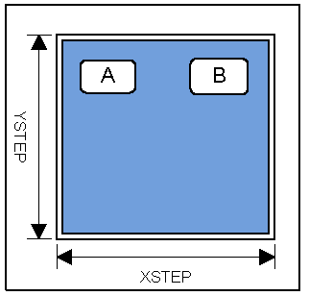

The back side of the capacitor comprises of conductive silicon which mandates the use of non-conductive epoxy for die attach. The capacitors are passivated with an additional silicon nitride topside layer to protect the die during pick and place handling.
Custom capacitor layout, values and tolerances are available as
special orders.

The available capacitance range
for this format is 20pF to750pF.
The Breakdown Voltage (BV)
Varies, depending on the
capacitance value, the lower
the C, higher the BV.

Electrical Specifications(1)

Parameter | Symbol | Conditions
Capacitance | C | 1 MHz, 1 V rms, 100% electrically tested
Temperature Coefficient of  Capacitance | TCC | +45 ±25 ppm/°C
Operating Temperature Range | TOP | -55°C to +125°C
Insulation Resistance | IR | > 1010 ohms
Aging | AR | No aging effect
Working Voltage | WV | Maximum continuous operating voltage
Breakdown Voltage | VBR | > 1.5 X Working Voltage

(1) All measurements at 25°C unless otherwise specified

ORDERING PART NUMBER
SATC | 330 | K | 7 | A | W
Product  Family | 3-digit Capacitance Code | Capacitor  Tolerance | Device  Thickness | Back Metal for Die Attach  (Typical thickness) | Package Type
 | Capacitance Code  Examples: 068 = 68pF and  510 = 510pF | J = ±5% | 9 = 9 mils | No Letter = Bare Silicon  (No Back Metal) | W = Unsawn full 5" wafer
 | Capacitance Code  Examples: 068 = 68pF and  510 = 510pF | K = ±10% | 7 = 7 mils | A= Ti/Ni/Au  (550A/4,000A/2,500A) | B = Diced and shipped on mylar/tape in Saw rings
 | Capacitance Code  Examples: 068 = 68pF and  510 = 510pF | M = ±20% | 6 = 6 mils | S = Ti/Ag  (550A/5,000A) | P = Diced and shipped in  Gelpak

Part Number Example: SiliconApps SATC330K7AW is a PolySilicon Capacitor; 330pF ±10%;
having 7-mils thick with Ti/Ni/Au back-metal and shipped as unsawn wafer

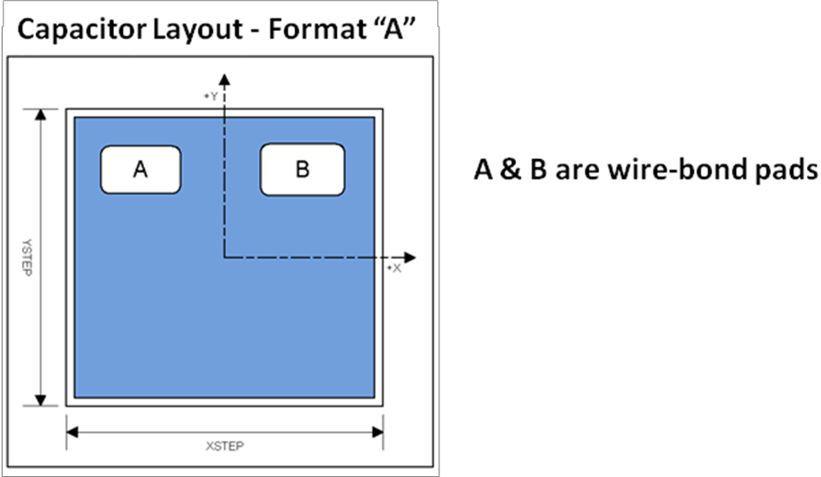

Physical Dimensions
Parameter | Symbol | Dimension | Units
Capacitor Length (typical) (2) | L | 0.94 / (0.0370) | mm / (inches)
Capacitor Width ( typical) (2) | W | 0.88 / (0.0346) | mm / (inches)
Capacitor Thickness | T | 0.18 ±0.02 / (0.0071) | mm / (inches)
Die Stepping Distance on Wafer in X Direction | XSTEP | 990 | microns
Die Stepping Distance on Wafer in Y Direction | YSTEP | 930 | microns

(2) Final L, W dimensions depend on conditions and equipment used for wafer sawing. Values shown above reflect a 50 micron wide kerf.

Bond Pad Coordinates
Pad | Parameter | X | Y | Units
Pad A | (3)  Center of Bond Pad | -260 | 275 | microns
Pad A | Width of Passivation Opening | 250 | 150 | microns
Pad B | (3)  Center of Bond Pad | 240 | 275 | microns
Pad B | Width of Passivation Opening | 260 | 160 | microns
(3) Pad locations referenced to the center of the die. The +Y direction is away from the wafer flat

